An Assessment of Performance Appraisal among Private Bank Employees

Sourav Basu ¹, Dr. Somnath Roy Choudhury ²

¹ Research scholar, Department of Management, RKDF University, Ranchi, Jharkhand
² Assistant Professor, Department of Management, RKDF University, Ranchi, Jharkhand

Abstract: Information about an employee's relative value is gathered, evaluated, and documented during the performance evaluation procedure. The primary goals of a performance review are to assess and enhance the employee's current and upcoming contributions to the company. The present study aims to find out the performance appraisal among the private bank employees, to Study the performance appraisal in relation to gender and to find out the performance appraisal in relation to experience. For this purpose the researcher has taken a sample of 456 private employees working in different private banks located in Kolkata, West Bengal. A survey questionnaire consisting of 23 items dealing with the statements of Performance Appraisal has been used for data collection. Collected data were tabulated and analyzed in the SPSS. 20 versions Descriptive statistics, t test and ANNOVA have been used for data analysis. Findings of the study indicate that Performance appraisal is of higher importance among the private bank employees, Male employees have higher performance appraisal than the female employees and there is significant difference in the performance appraisal between male and female employees in private bank.
Keywords: performance, Information, employees, gender, banking sector.

Introduction: Execution Appraisal is a significant part in any relationship to assess the representative's exhibition. It helps in assessing the representatives work culture, contribution, and fulfillment. Association through this choose workers advancement, move, motivations, pay increment. In any association representatives perform better as they get appreciation on their presentation. At the point when their exhibition is assessed they get propelled and remunerated likewise by any association. There is an immediate association between Performance Appraisal and occupation execution of the workers. No evaluations lead to the presentation of a representative as then, at that point, they will perform well once more. In the relationship of execution evaluation and occupation execution, there can be going between called natural inspirations. Natural inspiration can improve the relationship; positive work execution can be considered because of inspiration. This examination has been directed to discover the connection between execution evaluation, efficiency and work inspiration.
Performance appraisal, as defined by Flippo, "is the systematic, periodic, and an important rating of an employee's excellence in matters pertaining to his present job and his potential for a better job"
Simply put, a performance review is an in-depth analysis of how well each employee is doing their job. Knowledge of the work, product quality and amount, initiative, leadership characteristics, oversight, discernment, cooperation, reliability, health, etc. are just some of the criteria used to evaluate success. Evaluations shouldn't be based solely on results from the past. Employees' ability should be evaluated in light of their expected future success.
"Performance evaluation can also be understood as an official, organized method for evaluating and measuring an employee's work. The how and why of an employee's current performance on the job can be studied by measuring associated behaviour and results. And to learn how to improve future performance for the good of the individual, the company, and society at large”.
“Performance Appraisal is the formal assessment of the work performance of the employees and their growth potential over a certain period of time. Performance is a subjective matter and differs from employee to employee depending on their personal backgrounds, knowledge-skills, experiences abilities, &aptitudes etc. which determine the requirement of training & development. It can be considered as are port-card of an employee which shows of their performance assessment. Hence, management has to indispensably identify such factors differences to reward the employees performing better and also to keep a check on the wrong placements and weak performers.
Review of Literature:
Begum. S et al (2015) Performance evaluation is regarded as a crucial factor in corporate management. The main responsibility of the human resources department is performance appraisal. They are informed in advance about team members' performances by the relevant team leaders and managers. The department of human resources is showing interest in estimating the size of the workforce in their company. The performance appraisal system for the public and private sectors is discussed in this article. The methods used by managers in all industries to keep the finest personnel with their firms in order to accomplish their objectives are highlighted in this article.
Khan. Z (2017) the study examines the impact of staff incentive on performance and evaluations of their work. The results indicate that performance evaluations are a reliable indicator of employee success at business institutions in Dera Ismail Khan. Among 150 bank employees in Dera Ismail Khan, researchers discovered that intrinsic drive was a significant component in both job satisfaction and job success. “There is no evidence that employee motivation moderates the relationship between performance appraisal and performance, as shown by the fact that Model 2 with the interaction between performance appraisal and employees' motivation accounted for more variance than just performance appraisal and employees' motivation level alone (p =.168)”.
Sharma. A (2018) An employee's or a group of workers' performance in their current position as well as their potential for advancement in the future are often evaluated during a performance evaluation. It is the methodical evaluation of a worker's job-related strengths and deficiencies. Employees get feedback from it so they may understand where they stand and enhance their performance. Consequently, it aids in both their professional and personal development. Here, we look at how workers responded to and perceived their performance reviews. On the other hand, work happiness and productivity are positively correlated. Actually, job satisfaction refers to how happy workers are with their jobs and with the work they do. Employee turnover is closely correlated with job satisfaction. There were a lot of variables that were taken into consideration based on age, experience, and gender to determine how bank workers felt about performance reviews and the extent to which they were satisfied with their jobs. Hence in conclusion it is mentioned that perspectives of male workers and female employees are virtually comparable in maximum variables of performance rating. However, workers of various age groups have varying opinions on practically every aspect of performance review.
Statement of the Problem: Looking around, one can see that managing people in an organization has become more important over time. From multi-billion dollar corporations to tiny production companies, each has a specialized department (HRM) that is responsible for managing the business's workforce. In the organizational structure of the twenty-first century, human resource management is seen as the foundation for an organization's success. Among other crucial duties, the human resources division is trusted to keep a careful watch on how the workforce contributes to the accomplishment of the organization's goals and objectives, which is done via performance evaluation.
Need for the Study: Improper evaluation through Performance Appraisal techniques results in dissatisfaction among employees which in turn reduces employee productivity. Research on the subject matter has been done by numerous researchers but few of them attempted to explore the Banking sector. Performance evaluation of bank employees comprises of various determinants. Review of related literature depicts that research work on performance appraisal are mostly undertaken in educational institutions, BPO, service industry and IT industry while increasing evidence exists that performance-appraisal is important and impacts the employee’s performance in banking sector too. In this regard the current study is of dire importance.
Objectives: The main objectives of the study are as follows-
- To find out the performance appraisal among the private bank employees
- To Study the performance appraisal in relation to gender.
- To find out the performance appraisal in relation to experience.
Hypothesis: The researcher has formulated the following hypothesis-
Hp1- There is higher importance of performance appraisal among the private bank employees
Hp2- There is significant difference in the performance appraisal among male and female private bank employees.
Hp3-There is no significant impact of experience on the performance appraisal among the private bank employees.
Methodology:
POPULATION: Population for the present study consists of the people working in different private banks in Kolkata, West Bengal.
Sampling: The sampling method used in the study is non – probability sampling. It is a systematic sample with critical premises. To gather sample of representatives in banking area an aggregate of 500 surveys were circulated to the respondents. Out of 500, 456 questionnaires were gotten.
Data Collection: The collection of primary data was finished utilizing individual examination and field studies which incorporate advancement of questionnaire and directing the survey on the example distinguished. In directing the overview representatives from various divisions at all levels were haphazardly drawn nearer actually and through sends to fill in the survey questionnaire. The questionnaire was consisting of 23 items dealing with the statements of Performance Appraisal.
Statistical Techniques: Collected data were tabulated and analyzed in the SPSS. 20 version. Descriptive statistics, t test and ANNOVA have been used for data analysis.
Data Analysis and Interpretation:
Gender | No. of Respondents
Male | 236
Female | 220
Total | 456
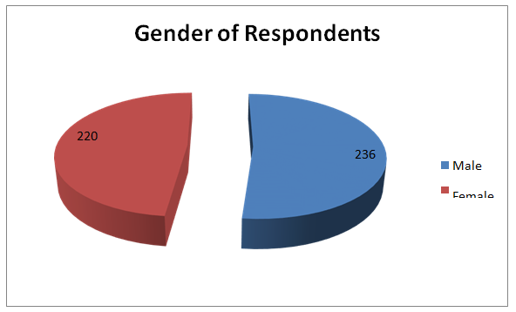
Fig.1

EXPERIENCE OF RESPONDENTS
Experience | No. of Respondents
Lessthan2years | 154
2 years to 5 years | 176
more than 5 years | 126
Total | 456

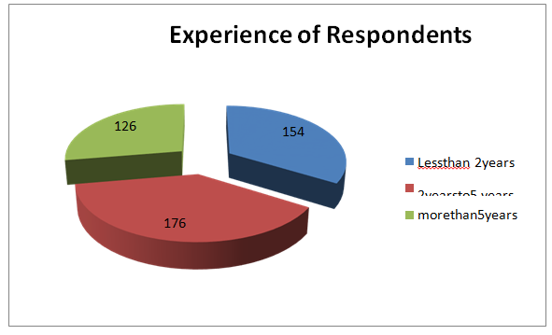
Fig.2

Table-1: Descriptive Statistics of Performance Appraisal
N | 456
Minimum | 40
Maximum | 108
Range | 68
Mean | 79.17
Median | 83
SD | 16.564
Variance | 274.38
SEM | 0.775
Skewness | -0.467
Kurtosis | 2.347

The above table shows the descriptive statistics for performance appraisal. It is clear that the mean score is 79.17 with the minimum range 40 and maximum range 108. The SD is 16.564, SEM is 0.775. The mean score shows a higher performance appraisal among the private bank employees.
Table 2–: performance appraisal between male and female
Variable | N | Mean | SD | SEM | df | t
Male | 236 | 79.43 | 16.647 | 1.08363 | 454 | 1.3052
Female | 220 | 77.45 | 15.679 | 1.05708 | 454 | 1.3052

From the above table it is evident that the mean score of performance appraisal among the male employees is 79.43 and SD is 16.647 and among the female employees the mean score is 77.45 and SD is 15.679. The calculated t value is 1.3052 which is less than the critical value 1.99. Therefore the formulated hypothesis “There is significant difference in the performance appraisal between male and female employees in private bank” is accepted.
Table-3: One Way Annova for Performance Appraisal in relation to Experience One Way Annova Data Summary
Groups(Experience | N | Mean | SD | Std. Error
Less than 2 years | 154 | 76.3377 | 16.7781 | 1.352
2-5 years | 176 | 76.3068 | 16.6455 | 1.2547
More than 5 years | 126 | 76.0476 | 17.5448 | 1.563

Source | df | Sum of Squares | Mean Square | F | P
Between Groups | 2 | 6.9052 | 3.4526 | 0.012 | 0.988
Within Group | 453 | 130035.428 | 287.0539 | 0.012 | 0.988
Total | 455 | 130042.3332 | 287.0539 | 0.012 | 0.988

To discuss the performance appraisal in relation to experience One Way Annova has been used. Table 14 addresses the model outline which comprises of the sum of square and df, variance and F. The F is 0.012 with the p value of 0.988. This shows a positive connection between the performance appraisal and years of experience and we neglect the formulated hypothesis “There is no impact of experience on performance appraisal”.
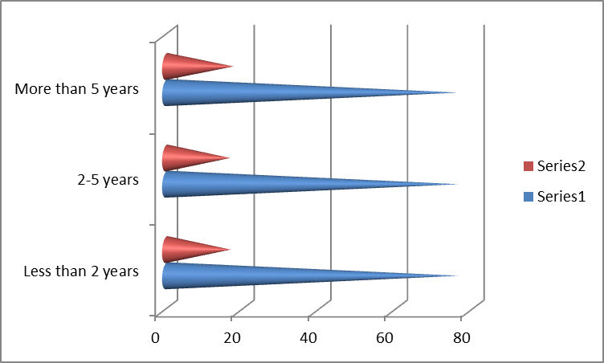
Fig.3: Showing Mean, SD of performance Appraisal in relation to Experience Annova Summary
Findings:
- Performance appraisal is of higher importance among the private bank employees.
- Male employees have higher performance appraisal than the female employees.
- There is significant difference in the performance appraisal between male and female employees in private bank
Recommendation:
- Appraisal structures ought to be overhauled and field tested, which ought to be straightforward, rapid and discrete.
- In request to be powerful, responsibility and backing for the performance appraisal, progressed measure is needed from the HR division
- The performance appraisal framework ought to be completely coordinated into the current administration frameworks and cycles

